Ransom Ministries strives to generate conversation about faith and who Jesus is with our logo, T-shirts and other materials. So many logos are self-explanatory, but that's not our goal — instead, we want to pull ourselves out of our comfort zones! We want people to ask, “What does that mean?” This gives us yet another opportunity to share the love of Christ one-on-one with the people around us.

If you are asked about Ransom's new logo, please share both the origins of the symbols as well as what each symbol means to you in your walk with Jesus.

BE SALT
We are all called to be salt in Matthew 5:13: “You are the salt of the earth. But if the salt loses its saltiness, how can it be made salty again? It is no longer good for anything, except to be thrown out and trampled underfoot.” Salt has two uses: to give flavor and preserve. We are called to give flavor to and preserve the culture and people around us by being a positive, involved, Christlike presence in our communities. However, we should also remember that too much salt is unhealthy, so while we must be salt, we should not be overbearing or pushy.

THE SYMBOL
The symbol for salt comes from the Alchemical symbols, which were used to denote elements and compounds until the 18th century.


BE LIGHT
We are called to be light in Matthew 5:14: “You are the light of the world. A town built on a hill cannot be hidden.” We are to shine like a lamp (not a spotlight) so people may see this Jesus we love through our lives, as well as the love we have for others through our interactions with them.

THE SYMBOL
The symbol for light comes from electrical symbols used by electrical contractors. On a set of electrical plans, this symbol represents a source that generates light when an electrical current flows through it. This symbol is personally meaningful to Ransom Ministries because of God's provision through a job in the electrical industry that allowed Matt to start Ransom.

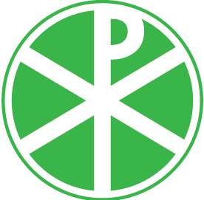
BE JESUS
In 2 Corinthians 5:20, Paul tells us that we are ambassadors for Jesus: “We are therefore Christ's ambassadors, as though God were making his appeal through us.” As ambassadors of Christ, we strive to emulate Him in the way we treat people, love people and carry ourselves on a daily basis. This is why Ransom Ministries exists — we want to be a picture of Jesus' love for everyone in our community.

THE SYMBOL
The symbol for Jesus is a combination of the first two letters (XP, or Chi Rho) of "Christ" in Greek. The X and the P are superimposed to create what is known as the Monogram of Christ, Chrismon or Labarum. While it was used long ago by persecuted early Christians in the catacombs, the circle around it represents eternity.

